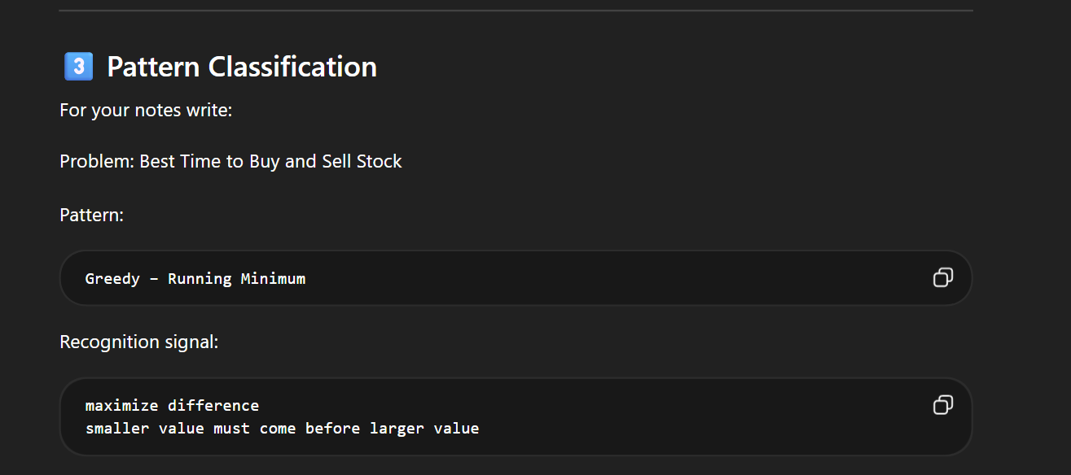

BRUTE FORCE :
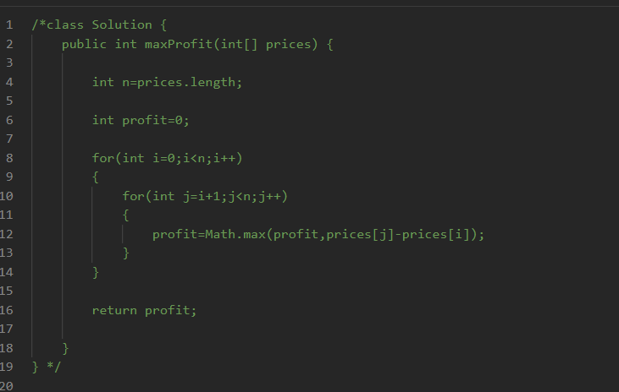

OPTIMAL APPROACH :
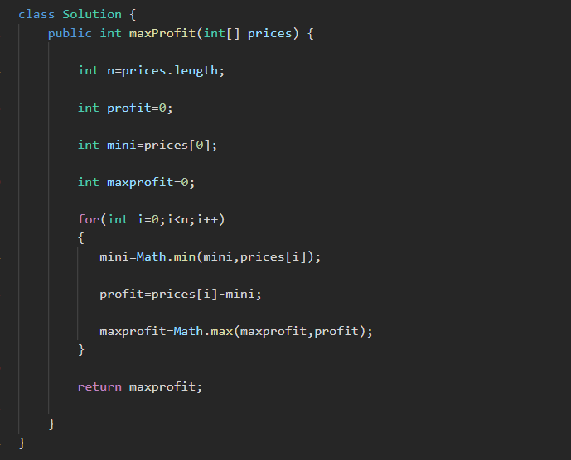

KEEP TRACK OF MINIMUM IN EACH ITERATION THEN SUBSTRACT IT WITH PRICES ON ALL DAYS

LINK ::
https://leetcode.com/problems/best-time-to-buy-and-sell-stock/submissions/1937909971

